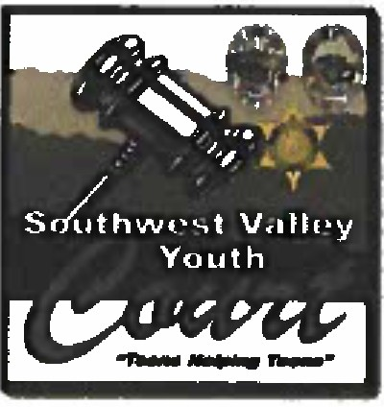

The Murrieta Police Department, Menifee Police Department, and Riverside County Sheriffs Department (Southwest) will be hosting a training for those students interested in volunteering for the Southwest Valley Youth Court.

Youth court is a juvenile diversion program using restorative justice to offer an alternative sentencing method to address juvenile offenders. Youth court holds first time offenders accountable, educates them on the criminal justice system, and provides a meaningful forum for youth to practice and enhance their communication and leadership skills.

Youth volunteers actively learn the roles and responsibilities of the various parts of the judicial system by volunteering as a **Youth Juror** or **Youth Attorney.** Youth courts offer a powerful set of civic opportunities for the youth in our communities.

*This training is open to all high school students in the cities of Murrieta, Menifee, and Temecula.*

Participation Requirements

# *Youth Court volunteers must meet the following criteria:*

Must be a current high school student in good academic standing Must abide by the rules of the program

Must complete application and sign an "Oath of Confidentiality" Must demonstrate maturity and sensitivity

# *Volunteers will receive community service hours for their service.*

**When:** May 111\ 2023, at 6:00 P.M.

**Where:** Murrieta Police Department 2 Town Square Murrieta, CA 92562 Please RSVP to Corporal Matt Mozingo

Phone: 951-461-6375 or Email: [mmozingo@murrietaca.org](mailto:mmozingo@murrietaca.org)

**Sessions Attended**

1. Dee Hankins
2. Welcome Your Students Home
   1. 1st day of school plan canvas page for the staff with all of the activities as well as a printed packet for those who need it
3. The Servant Leader
   1. Kindness journals
   2. Shadow Day - 8th grade leaders are on campus to shadow leaders on campus
4. Day of Understanding
5. All in Leadership day
6. Everyone Matters!
   1. Bronco of the Week - BOW
   2. Diamond in the Rough
   3. Heart of a Bronco
   4. Teacher's choice awards
   5. Every staff member is thanked over the course of the year.
7. Question Every Day
8. Representation Matters!

Quick Wins

* Resilience is Everything
* You are allowed to dream, and you are allowed to make it happen
* I can, I will, watch me.
* Everyone is a leader, even when you do nothing.
* I want you to walk out of here better than when you walked in
* Maturity is action not an age or gender.
* We have everything in this room that we need - it's the people.
* Plan the plan - work the plan.

Building Broncos

* How can J Serve you - putting the Sin class
* Staff Spotlight - video of kids talking about teachers and staff who have made an impact. o Can we make this happen for the end of the year?
* Document with all staff members - can we keep track of who we recognize?
* If Representation doesn't matter to you it's because you are already represented
* Can BNN work with the CCC to provide info on service opportunities.
* How do we support teachers building their own leaders
* How can we build a system that gets our team all working in the same direction?
* Trailblazers - Microsoft Form. Email notification when someone submits a form. Link provided to staff in the weekly Ranch Report email.

Big Ideas-CLASS Academy

* Freshmen leadership classes during office hours - learn the skills they need to become successful leaders on campus. Not an ASB class - a true development of leadership.
* 5 sessions September, October, November, January, February. Celebration in March as students prepare for applying to leadership on campus.
* Office hours. Sessions lead by leaders. Max 100 freshmen.
* Invite those who didn't make it to ASB or another leadership group. Ask teachers for recommendations in August.
* Focus on CLASS one letter each session.
* Provide certificate and celebration (Ice cream party?) when students have completed all five sessions.
* Letter of recommendation to sophomore leadership when they have completed 5/5 sessions.